## **Week 6 Homework: Advanced Bash - Owning the System**

### **Overview**

Congratulations! You've made it to the end of the Linux module.

Over the past few weeks, you've played the role of a systems administrator responsible for diagnosing, securing, and automating the hardening of a compromised Linux host. In doing so, you've explored all of the following, and more:

* The structure of the Linux file system.
* Processes and how to inspect them.
* Creating users and groups and editing their permissions.
* Scheduling regular jobs with cron.
* Logging, monitoring, and log analysis.
* Automating common tasks with bash scripts, compound commands, and other advanced features of the shell.

Getting this far is a real accomplishment. This is a huge amount of information, all of which is used by professional systems administrators almost every day.

### **Scenario**

In this week's homework you will play the role of a hacker. You will remotely access a victim's target machine, maintain access using a backdoor, and crack sensitive passwords in the /etc directory.

You will be learning a lot of new concepts in this homework, and you may need to do a bit of research. This homework should be a fun, engaging hands-on introduction to maintaining access to a compromised system. You will learn about this in more depth during the pentesting units. For now, read the section below on Privilege Escalation to better understand the setup and goal of this assignment.

* **Note:** This activity is based on the "offense informs defense" philosophy. You will practice taking the role of a criminal hacker in order to better understand how exploits are carried out. Remember: to protect from attacks, you'll need to practice thinking like an attacker.

#### **Privilege Escalation**

When an attacker gains access to a machine, their first objective is always to escalate privileges to root (which you accomplished during your scavenger hunt activity). When they achieve root privileges, they can do anything they want to the system. Cybersecurity professionals describe the process of gaining access to a host and escalating to root privileges as **owning the system**.

While owning a system is a crucial piece of the process, it is only the first item on an experienced attacker's agenda. Two goals remain on the checklist: **maintaining access** and **exfiltrating data**.

After exploiting a machine, attackers must ensure they will be able to reconnect later with the same escalated privileges they gained during the first assault. This is typically achieved by installing a **backdoor**. A backdoor is any mechanism that allows an attacker to secretly reconnect to a machine they've exploited.

### **Lab Environment**

You will use the Attacker Machine to carry out your activities on the Target Machine. If you are using the Vagrant local machine, follow the steps below. The machine which will simulate a remote machine (the attacker) on the internet that an attacker would use to hack into an organization's servers (the target).

Complete the following steps to set up your Vagrant local machine:

1. Ensure that you have VirtualBox and Vagrant installed on your local machine.
2. If your computer has limited resources, make sure you shut down other virtual machines, such as the Linux VM and linux-scavenger VM, as you'll be launching two new ones soon.
3. Move the Vagrantfile located in this homework directory to your local machine. You can save this file locally to any directory that is **not** one of the following (as they already have a Vagrantfile):  
   * $HOME/Documents/Cybersecurity-Bootcamp/Linux-Module: This contains your ongoing Linux Ubuntu VM that you'll use again in two weeks.
   * $HOME/Documents/LabEnvironments/linux-scavenger: This contains the VM from your scavenger hunt.
4. After saving the Vagrantfile, open a terminal window (Git Bash for Windows users) and navigate to the directory where you saved Vagrantfile.
5. Launch the lab by running vagrant up. Leave this Vagrant terminal window open.  
   * Note that after the machines are set up, you can shut them both down by running the command vagrant halt.
   * If you have any issues at this or any installation step, please reach out to your instructor or TA. This is most likely due to a root ownership error.

Depending on your internet connection and your local machine, it may take a few minutes for Vagrant and VirtualBox to set up your machines.

During this process, Vagrant is setting up two VirtualBox VMs and giving them static IP addresses for you to use during this homework.

1. After Vagrant is done setting up the machines, you should have a Target Machine and an Attacker Machine in your VirtualBox Manager window. Both should now be launched.

Attacker and Target Machines in VirtualBox

#### **Access Setup**

Get started by logging into the target machine as root:

1. Load up your attacker machine and log in with the following credentials:  
   * Username:
   * Password:
2. Begin an SSH session into the target machine by doing the following:  
   * Open a terminal on the attacker machine and run: ssh sysadmin@192.168.6.105 -p 22.
3. This command will attempt to start an SSH session on your target machine.  
   * Enter the password passw0rd when prompted.
4. After you've successfully logged into the sysadmin account on the target machine, you'll notice your prompt changes to sysadmin:~\ $.  
   * Swap to the root user by entering sudo -s and reentering the password passw0rd.

You should now have the root prompt root:~\ $ that you acquired during your scavenger hunt activity.

### **Instructions**

* **Important:** Please fill out the Submission File as you complete your homework. This will be your homework deliverable for the week.

Your goal for this assignment is to maintain access to the target machine by installing a backdoor. You will then use the backdoor to crack sensitive passwords.

To complete this assignment, you must complete the steps below. Again, some of these steps will require you to research new tools and concepts. Any information you might need can be found using man pages and online searches. Remember: learning new tools on the job is a key skill for IT and security roles.

#### **Step 1: Shadow People**

In this step, you'll create a "secret" user named sysd. Anyone examining /etc/passwd will assume this is a service account, but in fact, you'll be using it to reconnect to the target machine for further exploitation.

1. Create a sysd user.
2. Give your user a password (make sure you remember it).
3. Give your user a system UID (any UID below 1000)
4. Give your user a GID equal to this UID

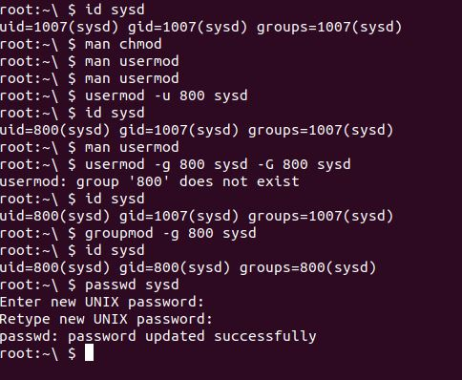

1. Give your user full sudo access without a password

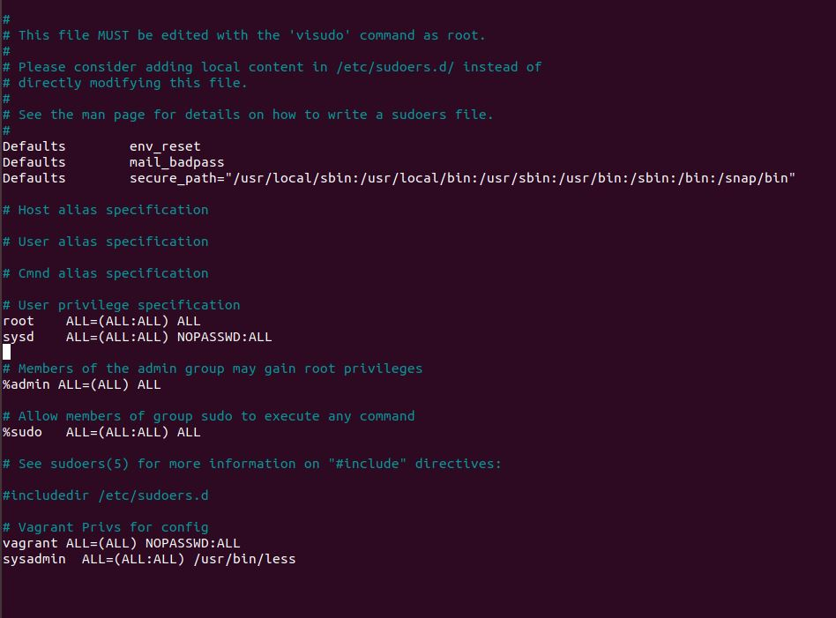

Minimize exposure by ensuring that your secret user does not have a home folder.

1. Test that your sysd user can execute commands with sudo access without a password before moving on.  
   * Try running sudo -l to test. If the terminal does not prompt you for a password, it was a success. Attempt any other commands that require elevated privileges and mark them in your Submission File.

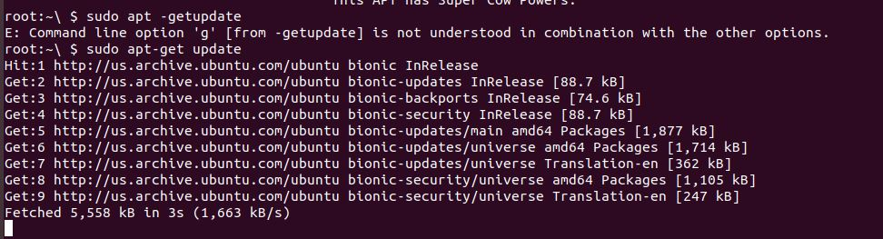

**Note**: If a hacker can rapidly execute commands on a machine with elevated privileges, they can more quickly exfiltrate important data from the target machine.

#### **Step 2: Smooth Sailing**

In this step, you'll allow SSH access via port 2222. SSH usually runs on port 22, but opening port 2222 will allow you to log in as your secret sysd user without connecting to the standard (and well-guarded) port 22.

1. Use Nano to update the /etc/ssh/sshd_config configuration file to allow SSH access via port 2222:  
   * When you open the configuration file, add a secondary SSH port line under port 22.
   * This will require some research. Start by examining /etc/ssh/sshd_config and using online searches or man pages to learn more about the available configuration options.

<https://www.thegeekdiary.com/how-to-configure-separate-port-for-ssh-and-sftp-on-centos-rhel/>

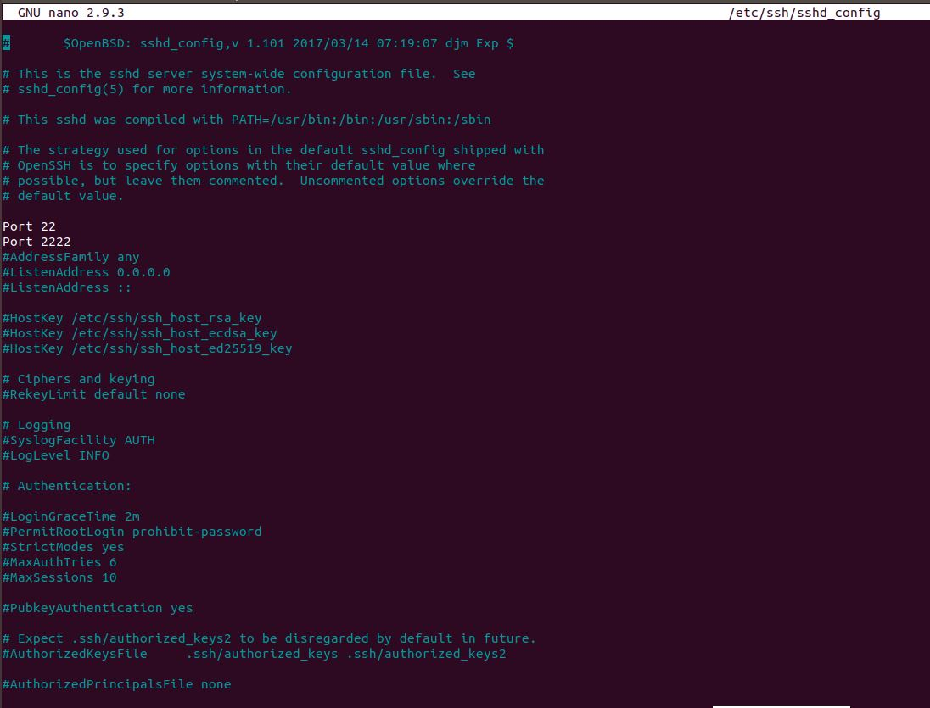

#### **Step 3: Testing Your Configuration Update**

When you think you've configured things properly, test your solution by testing the new backdoor SSH port. Do the following steps on the target machine:

1. First, note that the IP address of the target machine is 192.168.6.105. You'll need this for when you attempt to log back into the target machine.

* Make sure to restart the SSH service.

1. Exit the root account, and log off of the target machine (you'll know you're back in your attacker machine when the prompt turns green).
2. Use your attacking machine to test the new backdoor SSH port:  
   * SSH back into the target machine as your sysd user, but this time change the port from 22 to 2222 using: ssh sysd@192.168.6.105 -p 2222.
3. Once you are connected to the target machine over SSH, use sudo su to switch back to the root user.  
   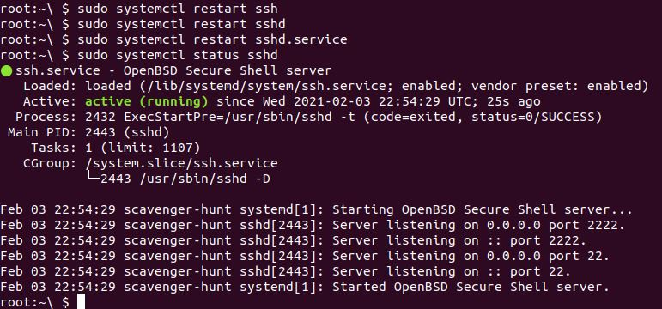

* **Note**: This is an important step. You were able to log out of your root account, and then reestablish a remote session with escalated privileges through a different, un-guarded port.  
  + Company servers that house sensitive information will often use monitoring and hardening tools to closely watch key ports, such as 22 for SSH.
  + It is also quite difficult for hackers, on their first breached connection, to know the locations of the most sensitive files in a system.  
    - For this reason, hackers need to both attempt to mask their activity (as you are doing with your sysd user), and also ensure they can discreetly revisit a system. This allows them to maximize the amount they can take from the target machine.

#### **Step 4: Crack All the Passwords**

Next, to strengthen our control of this system, we will attempt to crack as many passwords as we can.

Having access to all the accounts will also allow us to access the system if our other backdoors are closed.

1. Make sure that you have SSH-ed into the target machine using your sysd account.
2. Escalate your privileges to the root user. Use John to crack the entire /etc/shadow file.  
   * You will not need to transfer the file as John is already installed on the scavenger hunt VM.

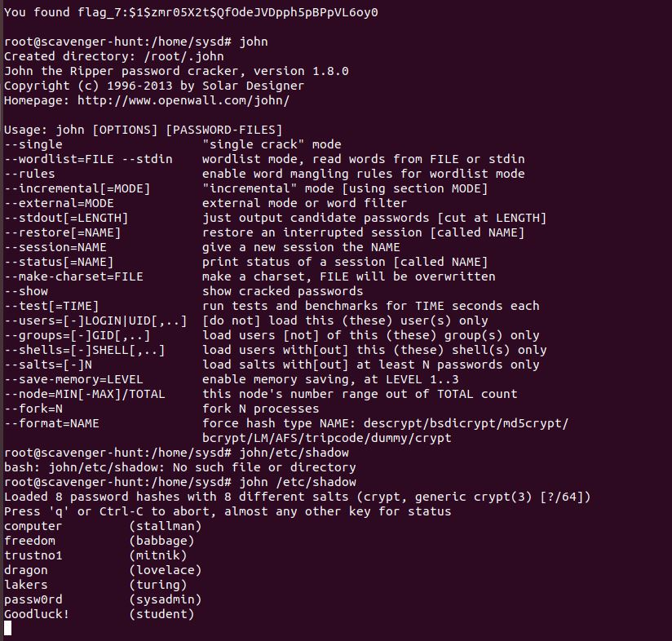

**Note:** Cracking passwords is a process that takes time. Now might be a good opportunity to take a break and let the computer do the work for you.